Chronology of Instrument Designs and Ideas

Sep-2016:

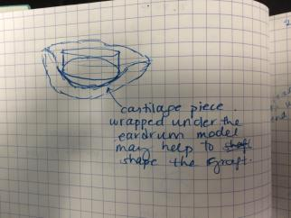

Problem: too much time to shape the cartilage graft in the appropriate shape. Solution: Cartilage 3D stencil to help shape the ear drum graft. A variant of this was tried before, and it took too long to print (too much time used) and the end result wasn’t perfect. Dr. James printed a 2D outline of the ear drum in that case.

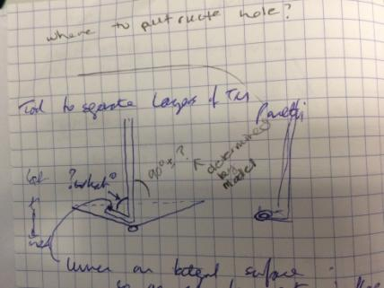

Problem: left and right Panetti suckers are not perfect – the bend angle is 90deg.

* 90deg not optimal for ear drum which is not perfectly flat
* 7What is the optimal bending angle for the Panetti sucker?

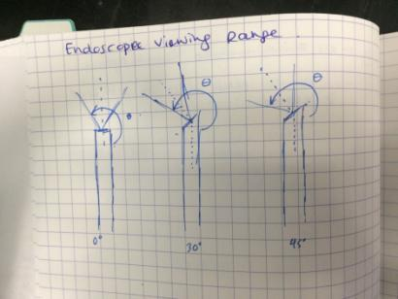

Problem: cannot reach the areas visualized by the endoscope. Need a tool that can bend around the endoscope to reach something.

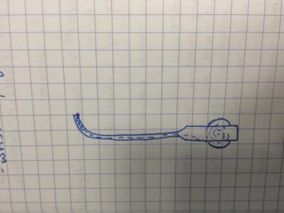

Can use a wrist or concentric tubes to reach into the viewing field of the endoscope. Problem: need to feed instrument in straight, alongside endoscope and then bend (could be done by an instrument with a permanent bend in the middle or a bendable tip e.g. concentric tubes or wrist)

Handle is actuated via dial for the thumb

Question: what is the tip doing? 🡪 Workspace analysis

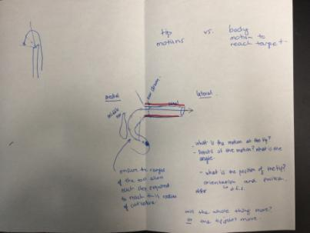

Workspace Analysis:

1. Tip Design

* Measure the orientation space using electromagnetic electrodes at the tip of a printed Rosen
* Measures the orientation of the tip while dissecting
* 3D print ear model for this

1. Body Design

* 3D printed ear model with orientation space and endoscope added to it
* Add a stick and play around with the geometries to figure out appropriate body angles/bends/curves to access certain regions – antrum and sinus tympani

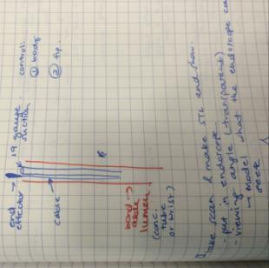

End effecter actuated via wires (e.g. forceps or curette) and suction down the lumen – like the Grace medical instruments but cut the tip of the lumen so the end effecter and suction are more closely integrated -> complicated handle design is not ideal for surgeons as they will have to learn how to use it -> make it easy and intuitive/native to the way that their current instruments work

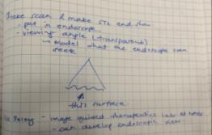

Make a surface STL that shows the direct view of the endoscope

Spoke with Harley (Mike Daley’s colleague) about this and he can make it as long as we provide a CT image with at least 0.5mm resolution, isotropic

If we publish using his contribution, we add him as co-author (that is his payment)

Oct-2016

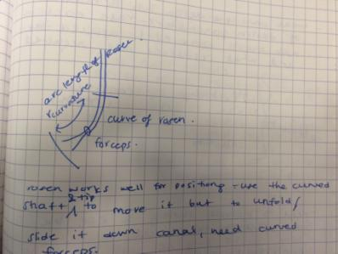

Curve forceps into Rosen needle bend to help facilitate graft movement

Graft introduction uses the forceps to place it into the ear canal first and then the rosen needle is used to slide it down the canal and position it

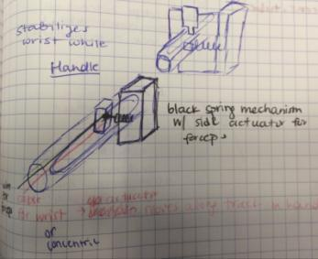

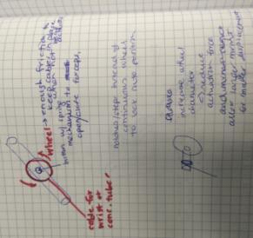

* Slider or dial mechanism to actuate concentric tubes and forceps
* Decoupled forceps and concentric tubes: use dial + button in the middle (probably only allows either open or closed, not in the middle)
  + Dial + slider underneath
* Coupled forceps and concentric tubes: use slider with button to actuate forceps (more control, able to half open forceps)
* Need to lock the dial in place – notches in the dial that locks the tubes in place
* Also want stiff tubes (as per feedback from EES course 19-Oct-2016) therefore lock would help that, and selecting the material, thickness
* Dial -> can calibrate the force vs. displacement -> wrap cable around thin axle attached to large dial -> large dial displacement = small cable displacement
* Use friction pads to ensure the dial doesn’t move to easily
* After the course – it seems that for greater adoption of tools, a very simple tool (without moving parts) would be more widely accepted
* The concentric tubes introduces the risk of how to retract the instrument quickly without having to think too much about how it got there – therefore, workspace study will be useful to figure out the appropriate geometry to permanently bend a sucker and its tip to access the necessary regions.

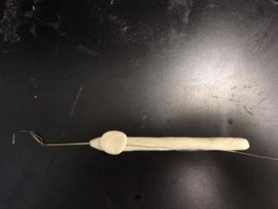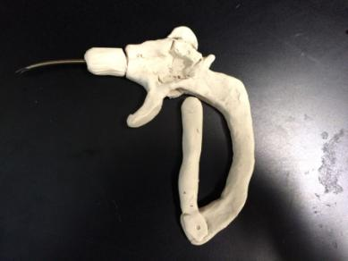

* Internal regulatory required for instrument use and publication needs REB
* Easier to get regulatory if the instrument is similar to existing (shape, function and material)
* If using the flexible wrist or concentric tubes, will be more complicated process to get approval to use in the patient

Nov-2016:

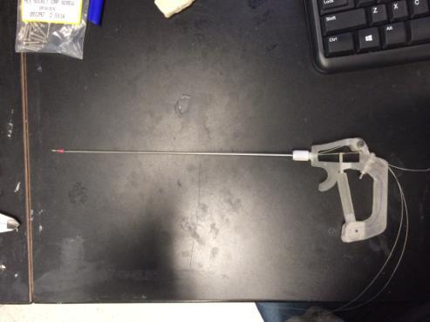

* First pass prototype
* Wheel was too small to actuate the wrist -> too much force required and not enough grip on the wheel to actuate wrist -> added protrusions so the thumb can use those to move the wheel
* Arm was too flimsy to actuate grippers
* Handle body didn’t fit in hand naturally -> changed shape so sits better in the palm

Prototype v-2:

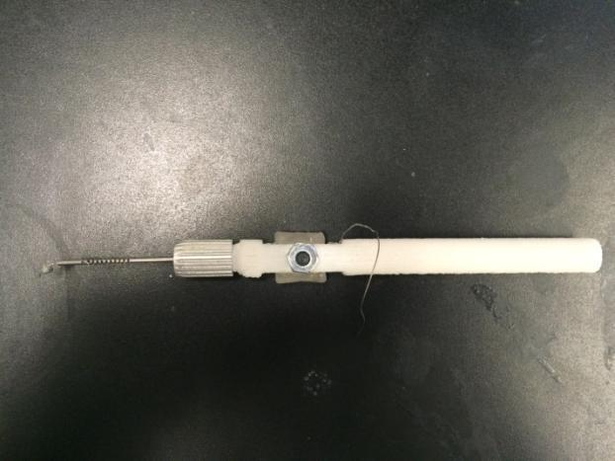

* Make the wheel larger and have more purchase for your finger
* Handle is a bit thicker than other instruments
* Integrating suction: got sheaths from needles (spinal tap needle) to use to cover the cuts/notches if using tool for suction
* Integrate a button to open/close forceps?
* Rosen needle curvature should be covered by the range of curvature of the tip

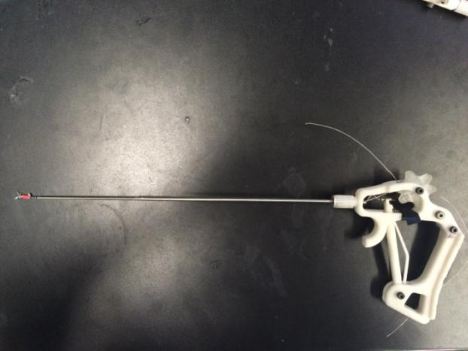

* Make the handle bigger to fit in palm
* Make the wheel have more protrusions (like a gear) for better purchase
* Angle the shaft so that the axis of rotation is the shaft -> ensure the shaft does not make an arc when the tool is being rotated

Dec-2016:

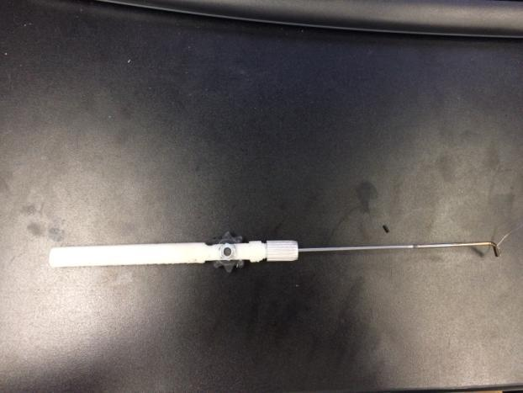

* Liked the wheel this time because of the gear
* Easy to actuate the tip bending
* Want the tip to be stiffer (will use optimal mechanical closure design for tip)
* Want to fit a lumen of 19gauge size inside for suction
* Could be feasible for E, N and T surgeries
* Run suction tube along the body of the tool

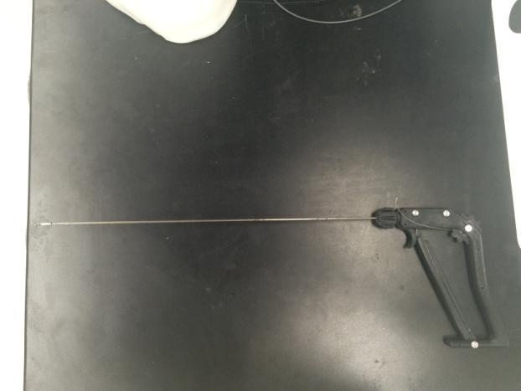

* For POP presentation
* Includes new tip cutting pattern for mechanical closure and stiffness
* Roll
* Forceps
* Wrist
* Form 1 printer for small parts
* Makerbot for larger parts

Wheel design:

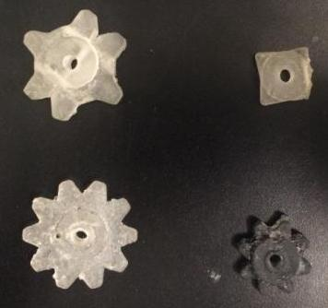

**4**

**3**

**2**

**1**

1: From Peter’s project, inserted the finger ridges onto it -> Too clunky, too many parts required as there are two halves that are joined together by two screws

2: not enough purchase for fingers, but thinner so easier to assemble

3: Too big, not enough purchase for fingers, hole to insert cable is not always printed and not a reliable print  
  
4: Small enough for the pen ent tool, good purchase for fingers – positive reception by Dr. James, but same problems with the hole   
  
Need to check if the wheel would interfere with the endoscope alongside it

24-Jan-2017:

**Instrument Design Decisions:**

**Tip:**

Material: Nitinol that will be cut into notches to allow the tip to bend

Cable – (get the details of the cable material and composition, why this specific cable is used to articulate the bending of the tip? – why do other instruments in the lab use it?)

**Geometry:**

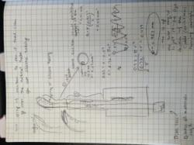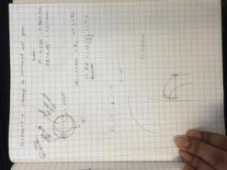

For suction that is desirable for TEES surgery in Dr. James’ OR: use 19 Gauge ID = 0.91mm

Cable OD = 0.3mm

Atube = Acable + A19gauge

= pi*0.15^2 + pi*0.455^2

= 0.721mm^2

* 0.721mm^2 = Atube = pi*rtube^2

Rtube = root(0.72/pi) = 0.479 mm

IDtube = 0.958mm at least to achieve the same cross sectional area as a 19 gauge sucker, as this tip has a cable of OD 0.3mm running through it, subtracting from the sucking cross sectional area.

Found a tube in the lab with the following dimensions:

ID = 0.0405” = 1.0287 mm

OD = 0.049” = 1.2446 mm

Sucking cross sectional area = pi*0.51435^2 = 0.83 mm^2 which is larger than the minimum cross sectional diameter required for this dimensional constraint.

**Tip Bending Angle:**

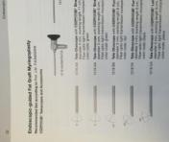from catalogue: “Endoscopic-Guided Fat Graft Myringoplasty – Technique, Equipment and Indications” page 22

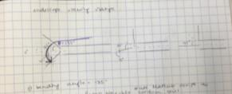

From the endoscope catalogue – for the 0 deg. Endoscope, the tool tip would have to bend the most to get to the viewing angle boundary (135 deg. = 3pi/4) vector pointing horizontal to vector pointing orthogonal to a line which is 45 deg from horizontal

From Kyle’s ASME paper, Rc = 2*Ro

Rc = 1.2446 mm

S = Rc* theta (bending angle)

= 1.2446*3Pi/4 = 2.93mm

From ANSYS simulation of Kyle’s cut geometry from that paper, a single notch with the ID, OD of this tube, will bend ~ 40deg. So if you have 3 cuts, 0.75 mm spaced out

Used solidworks to update the notch geometry to make each notch bend more so 135 deg could be reached.

* Want a longer arc length to reach over the endoscope
* Want to reach where the Thomissin can’t reach (Thomissin has short arc length)
* Start with blunt cut then do oblique cut later (like the left/right Panetti) – this would make it a good dissector, but the larger surface area of the tip might cause larger particles to be sucked in which would get stuck
* **Suction**: silicone sleeve – make it thinner (try an angiocath)
  + Can wet the silicone sleeve then mount it to make it easier to slip on
* Make two notched tubes – a) bending angle for the 45 deg. Endoscope b) for the 30 deg. Endoscope and when the tube is articulated then suction can occur and as soon as you release the bending, it would stop suctioning

Suction Tool Potential limitations:

* Arc length too large to fit inside the ear
* Ease of use for the surgeon to bend the tool and control its articulation
* OD of instrument – can it fit in anatomy?
* Stiffness – not stiff enough for dissecting, lifting, etc.
* Suction power – not strong enough, or suctioning from the slots
  + Clogging
* Reliability of the tip – fatigue and lifetime testing
* Sterilizability – disassembly required, how to make it easy to disassemble and reassemble

Feb-2017:

* Drawing instruments in a ‘slice’ of the ear canal
* If Suction instrument OD = 1.2446 + dx (dx=thickness added due to suction covering) then many spots can’t be accessed because the OD is too large
* Instead can make another manual tool where OD is smallest possible and use this like the Rosen (to reach and dissect)

“Steerable Robot-assisted Micromanipulation in the Middle Ear: Preliminary Feasibility Evaluation” (1)

* 6 DOF concentric tube robot
* workspace/reach compared with Rosen
  + optical tracker attached to tip while ‘operating’ in cadaver ear
  + Rosen needle and robot used to trace edges of the reachable area within bone to characterize size of workspace

Mar-2017:

* Making wristed suction prototype

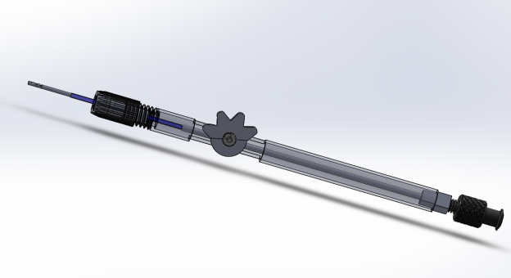

To do:

* Ensure handle is thin enough to fit with endoscope -> checked this on the solidworks virtual model V-1 08-Mar-2017 (C:\Users\arushri swarup\Documents\GitHub\Graduate-School\3D Models) and it should be able to fit
* Ordered materials:
* 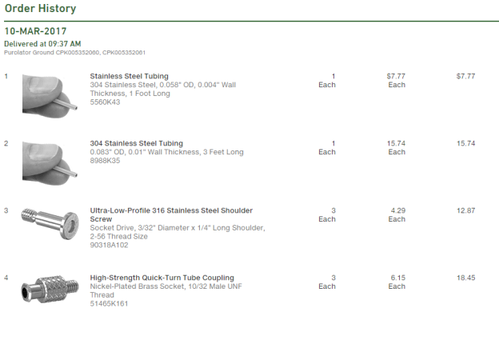rest of components are machined or 3D printed

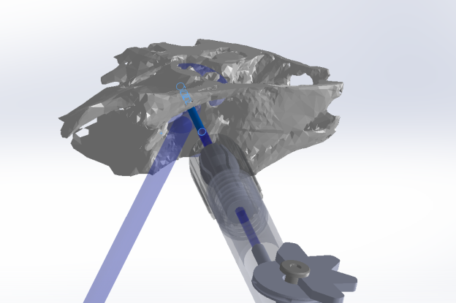

This shows the endoscope and instrument coming into the ear canal (the ear anatomy section is axially cut to expose the antrum and see the semi-circular canal (arrow is pointing to this)

This is just one position that allows both instrument and endoscope to fit, but would need a physical model to ensure that the appropriate positions can be reached

Budget and Materials 14-Mar-2017: C:\Users\arushri swarup\Documents\GitHub\Graduate-School\Ear Surgery Instruments

|  |  |  |  |  |  |  |  |
| --- | --- | --- | --- | --- | --- | --- | --- |
| **BOM for suction Wristed Tool** | |  |  |  |  |  |  |
|  | Component | Material | Dimensions | Supplier | Supplier P/N | Qty | Cost |
| Tubing Assembly: | |  |  |  |  |  |  |
|  | Wristed Tip | Nitinol Tube | 1.24mm OD | Lab |  |  |  |
|  |  | laser cutting |  | Pulse Systems | quote Number |  |  |
|  | Stainless steel tube 5560K43, soldered to wrist | stainless steel tube | 1.27mmID X 1.47mmOD | McMaster Carr | 5560K43 |  |  |
|  | tube without cable, coupled to luer lock | stainless steel tube | 1.6mm ID X 2.11mmID | McMaster Carr | 8988K35 |  |  |
|  |  |  |  |  |  |  |  |
|  | collet 1.75 mm ID |  |  | Lab |  |  |  |
|  | Collet thread cap |  |  | Form 1+ 3D printed |  |  |  |
|  | Wheel Handle Body | Aluminum tube | 5/16in OD | McMaster Carr | 89965K451 |  |  |
|  | Ultra Low Profile SS screw 90318A102 |  | 3/32in, 2-56 | McMaster Carr | 90318A102 |  |  |
|  | Wheel |  |  | Form 1+ 3D printed |  |  |  |
|  | Luer end |  | 10-32 end | McMaster Carr | 51465K161 |  |  |
|  | Luer-tube coupler | Aluminum |  | Mill machined at Lab |  |  |  |
|  | Cable | ss | 0.3mm | Lab |  |  |  |

Apr-2017

* Updated the CAD

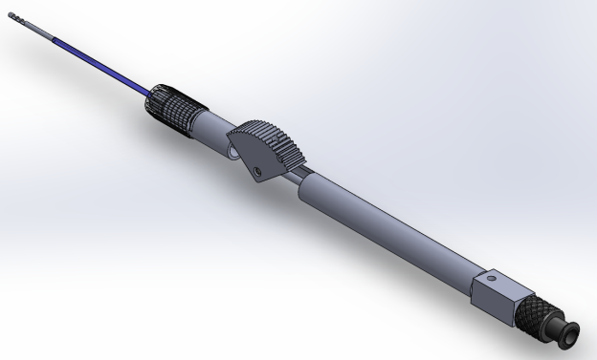

* Instrument idea: curved forceps – shape set into a predefined curve – inspired by Hamlyn design

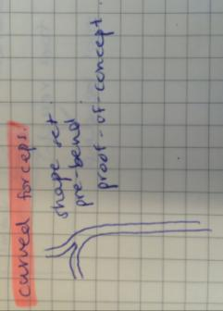

* Instrument idea: round knife on bendable tip but needs to be stiff!

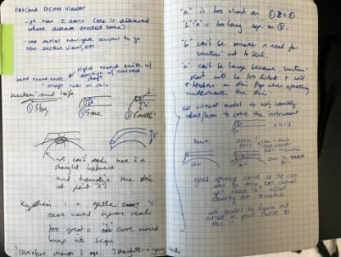

28-Apr-2017

Presented tool at 2nd World Congress for Endoscopic Ear Surgery

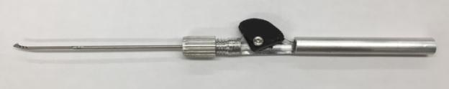

* Long and short tip, long tip reached boundaries of the mastoid
* Handle needs to have something that allows it to rest on the hands

Goal 1: Make tool bendable tip

Question: Notch cutting geometry? For simplicity, going with square notches -> What is the optimal arc length, radius of curvature to reach within difficult to reach areas?

* 9 CT scans form patients with difficult anatomy where bone had to be removed to access the disease – use the CT scans to measure curves that would fit
* cut out the scutum in the models and print
  + CT scans used to outline the antrum and the sinus tympani
    - On Solidworks drawing -> superimpose a tool drawing onto a cross section of the 3D model with the target area -> move the tool with curved tip around on the picture to see if it fits and can reach the intended area
    - Tool needs to be OD=1.24mm to be representative of the tool we are making
* Curvature:

|  |  |  |
| --- | --- | --- |
|  | **Radius of Curvature (Rc)** | **Arc Length (s)** |
| Min | Rcmin = 2*Ro = **1.24mm**  Smin = minimum arc length  Ro = outer radius of NiTi tube | S = rθ  S = 1.24*3pi/4 = **2.92mm**  To achieve bending angle = 135deg. To reach the boundary of the 0deg endoscope field of view |
| Max | S=Rc*θ  Rc = s/θ = 7.5/(3*pi/4) = **3.18mm** | **7.5mm**: distance between promontory (bony boundary of middle ear) and tympanic spine* |

*describes the max arc length that is limited by the anatomy of the middle ear – arc length should be less than the distance between the endoscope lens at the medial end of the ear canal where the middle ear begins and the promontory (promontory and tympanic spine (~7.5mm) this distance doesn’t change with age

* Distance between the sinodural angle and fossa incudis (1.7-3.5mm from Dahm paper) or sinodural angle and tympanic spine
* Dahm paper has measurements of temporal bone anatomy in patients aged 0-adult.

Need a random yet evenly distributed set of points for s and will generate tool reaching areas with fixed s and Rc ranging from minRc to maxRc -> superimpose that on top of cross section of 3D model to see if that s area can reach the intended spots.

Range of s: 6.6514 7.0685 3.5016 4.7000 2.9200 7.5000 4.1955 5.4247 6.1000 7.3392

Rc = [1.24, 3.18]

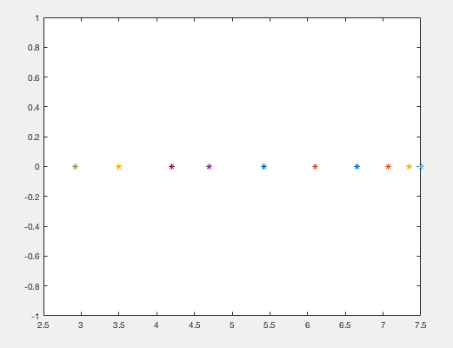

* + 3D print the models
  + reach behind lateral canal

Goal 2: Make tool tip functionality

* Integrate **graspers**
  + Biopsy forceps with notched cuts
  + Nitinol forceps with hinge
* Integrate **suction** – using the mechanical closure notch design
* Bendable round knife
  + Round knife needs to be welded on at the right angle

Goal 3: Tool Validation:

Q1: Can the surgeon reach where the disease was?

Q2: How much bone removal required to access the area?

Q3: Can the surgeon use the functionality of the tool at that area? E.g. is it possible to suck, grasp, laser, etc. there?

Q4: Human factors – how did the tool feel to the surgeon

**Paper on how to find the desired curvature:** (2) “Through the Eustachian Tube and Beyond: A New Miniature Robotic Endoscope to See Into the Middle Ear.”

* Uses a wristed nitinol tube (with notches cut into it) with an HD camera on the tip to create a steerable endoscope <2mm that can inspect the middle ear space by going through the Eustachian tube accessed through the nose
* CT scans of real patients -> 3D models to determine appropriate ranges for the endoscope diameter, length, required curvature
* In the computer 3D model, identified target points within the model, identified the straight path to get there (but had to stop before reached the ossicles, then identified curves from that straight insertion path to reach the targets this collection of curves was used to identify the curvature required to reach the target
* These paths identified to reach the target maximized visual coverage of the sinus tympani (area where cholesteatoma generally recurs), calculated the associated bending angle and arc length – calculation shown in reference [2] of the paper
* Endoscope field of view = 90deg
* chip-tip camera is the minnieScope-XS (Enable Inc., Redwood City, CA)
* nitinol tube: OD 1.8mm, ID 1.6mm
* sinus tympani anatomy: D. Marchioni, S. Valerini, F. Mattioli, M. Alicandri-Ciufelli, and L. Presutti, “Radiological assessment of the sinus tympani: Temporal bone HRCT analyses and surgically related findings,” Surg. Radiol. Anatomy, vol. 37, no. 4, pp. 385–392, 2015.

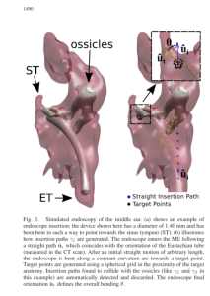

* From 6 high res CT scans

15-Aug-2017

* Took CT scans and identified targets for a tool to reach

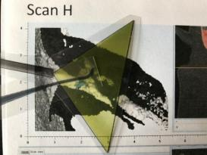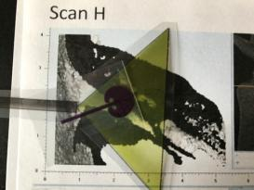

* Printed the 2D area of the tool with different arc lengths in the range identified earlier
* Printed the other instruments and endoscope with its viewing range to identify what anatomy would be visible and reachable
* This was a crude test to narrow down which arc length to set
* Results of pass/fail to reach target: C:\Users\arushri swarup\Documents\3D models\CT scans_May 2017\tool arc length and radius of curvature
* Shorter arc length = stiffer tip which is more desirable to manipulate tissue
* Longer arc length can reach farther within the middle ear

**TODO:**

**- make three new tools one at each arc length**

**- print ear models with target anatomy highlighted**

**- make suction-enabled prototype**

* Make three arc lengths: 2.92mm, 7.5mm and one in the middle (6.1 which was a pass for those targets)

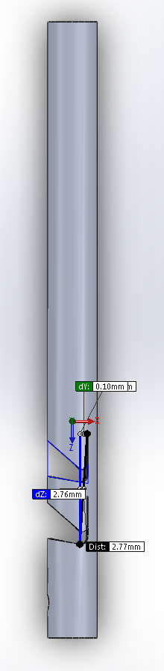 Tip 1: contact-aided mechanism notched tube. Laser cut, two notches, arc length = 2.76mm, but 3.1 mm from tip to top of notch (3.1 mm extra – including the hole to anchor the cable)

* Order components:
  + Ss shaft (connected to NiTi)
  + NiTi tubing (ensure the current size is good enough for suction first – order after making suction-enabled prototype)
  + Brass thread cap collet
  + Dye for aluminum handle that will fit on brass thread cap (M8X0.75)
  + Aluminum tube for handle
* Quote:
  + Laser cutting NiTi tube tips – from pulse
* CAD/print components:
  + Cable plug for suction tool
  + Enlarge the holes in thumb piece (1mm through hole) so that it’s easier to post-process

01-Sep-2017:

* **New Tool:** shape of the ear drum to dissect on the surface
  + Trace the curves on the ear drum surface -> make a mold out of that -> shape set nitinol tube -> attach to handle

Section of ear drum stl with lines traced on the surface: 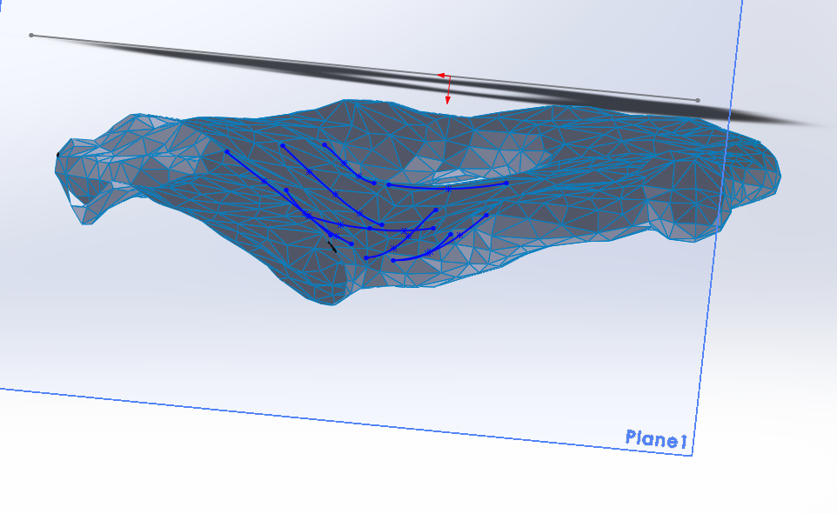

1. Yasin R, O’Connell BP, Yu H, Hunter JB, Wanna GB, Rivas A, et al. Steerable Robot-assisted Micromanipulation in the Middle Ear. Otol Neurotol [Internet]. 2017;38(2):290–5. Available from: http://content.wkhealth.com/linkback/openurl?sid=WKPTLP:landingpage&an=00129492-201702000-00022

2. Fichera L, Dillon NP, Zhang D, Godage IS, Siebold MA, Hartley BI, et al. Through the Eustachian Tube and Beyond: A New Miniature Robotic Endoscope to See Into the Middle Ear. IEEE Robot Autom Lett [Internet]. 2017;2(3):1488–94. Available from: http://ieeexplore.ieee.org/document/7855722/